Physical Development
*Physical literacy
*Listen and respond to music to make spiky, frosty movements and play games.
*Move like various arctic animals
*Make paper snowflakes to practice cutting skills
Develop cursive handwriting.

Expressive Arts & Designs
*Paint/collage arctic animals
*Paint with ‘cold’ colours
*Make icicles and snowflakes for the arctic ice cave role play area
*Use instruments to make spiky, frosty sounds
*Create a ‘snowy’ scene.
*Paint and make Christmas decorations, cards, and calendars.

Knowledge and understanding
of the world
*When is it winter?
*What happens to the weather, animals, and plants in winter?
*What do we do in winter?
*Why do we celebrate Christmas?
* Investigating snow and ice- melting and freezing work
*Finding out if everything freezes.
*Talk about what animals live in cold snowy places.
*Find out about Arctic and Antarctic
*Use maps to locate, find out about animals, people, and weather in cold places.
* Use a globe to talk about the North
and South Poles
*Find out about intuits.
*Look at why we celebrate Christmas and discuss Jesus and the nativity.
*Find out about Christmas around the world and how it is celebrated.

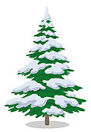
Personal, social, and emotional
*Look at ways to keep warm in winter clothes/eating/moving around/warm drinks.
*How do Inuit people keep warm?
*Talk about the ways that animals keep warm and safe in winter.
*Discuss the dangers of snow and ice
*Look at pictures of snowflakes close and talk
about how they are all different
*Make hot chocolate and share together after a winter walk/outside play
*Talk about Christmas and what it means to us all.
*Discuss gifts and giving and kindness.

Jan 2022
Reception

Communication & Language

*Small world play with arctic animals
*Role Play area – Ice Cave – using white sheets/boxes/make icicles and snowflakes with children/soft toy and small world arctic animals/glitter/arctic animal masks.
*Sharing ideas and news.

Mathematics

* Create a repeating patterned scarf
* Count icicles/snowmen/frosty spider’s webs and Christmas items outside
* Number recognition
* More or less (practical) Using arctic animals
* Compare size-wellies/scarves
* Continue to develop number sense, counting and addition skills.
* Practical addition/subtraction using winter objects/arctic animals
* Number ordering
* Number formation
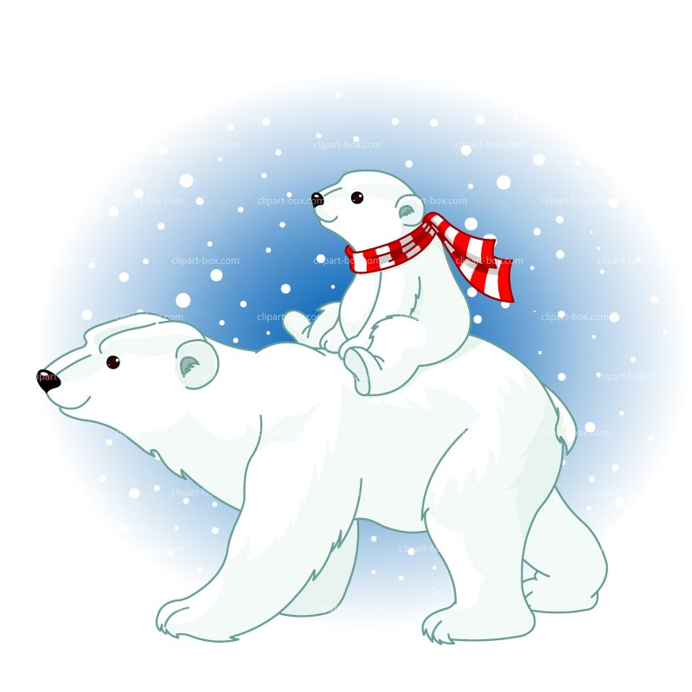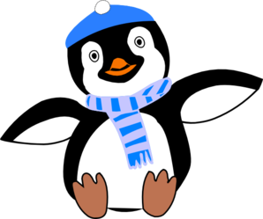

Literacy
*Read fiction and non-fiction books and poems such as The Snowman, Polar bears, Ridiculous etc.
*Phonics (continue to learn Phase 2 &3 sounds)
*Write simple sentences, lists and letters.
Sequence stories and answer questions about them.

Home Learning Challenge
- Can you find out about animals that live in cold places around the world and draw them?

- Can you paint a winter picture?

- Can you design a hat and scarf with repeating patterns?

