This week we have revised the previous terms sounds and tricky words. We havve also investigated the digraphs ‘ch’ and ‘th’. Please label the pictures below.
Tricky word spellings : we me be
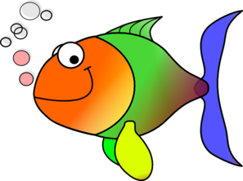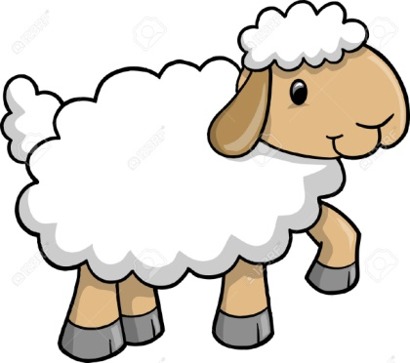

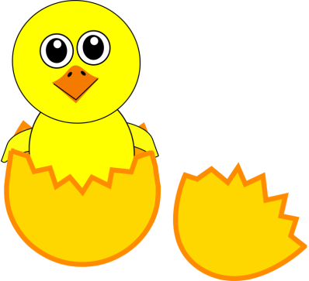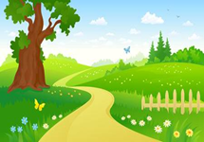

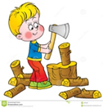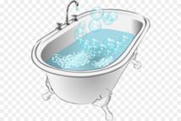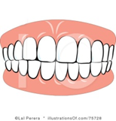

Adults the pictures are: chin, fish, sheep, shelll, chick, path, chop, bath, teeth.
Can you write a sentence about the picture below?


