This week we have focused on the ‘g’ and ‘o’ sounds .
Can you draw a picture of two things that begin ‘g’ and ‘o’.

Tricky words and spellings- and

Can you label the pictures below with all the sounds you can hear?
Can you write the word?

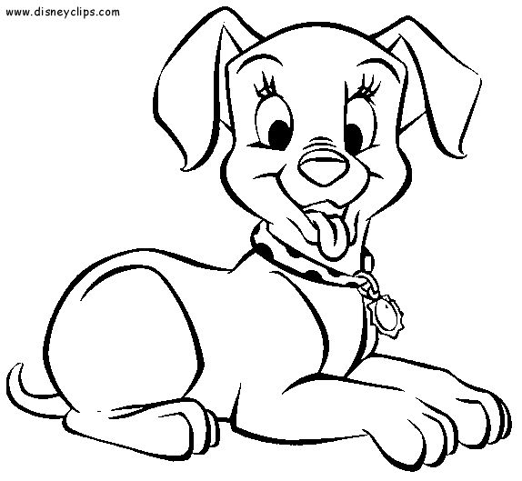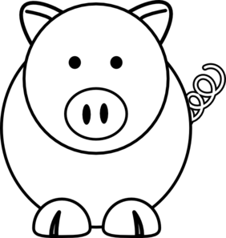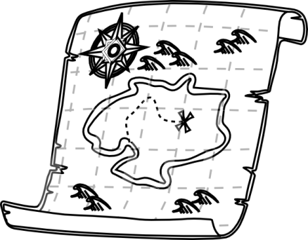

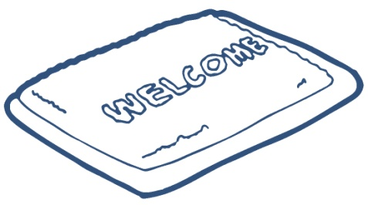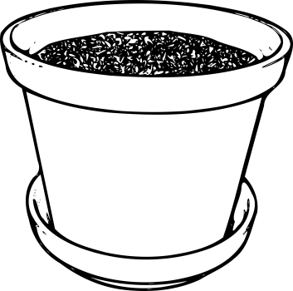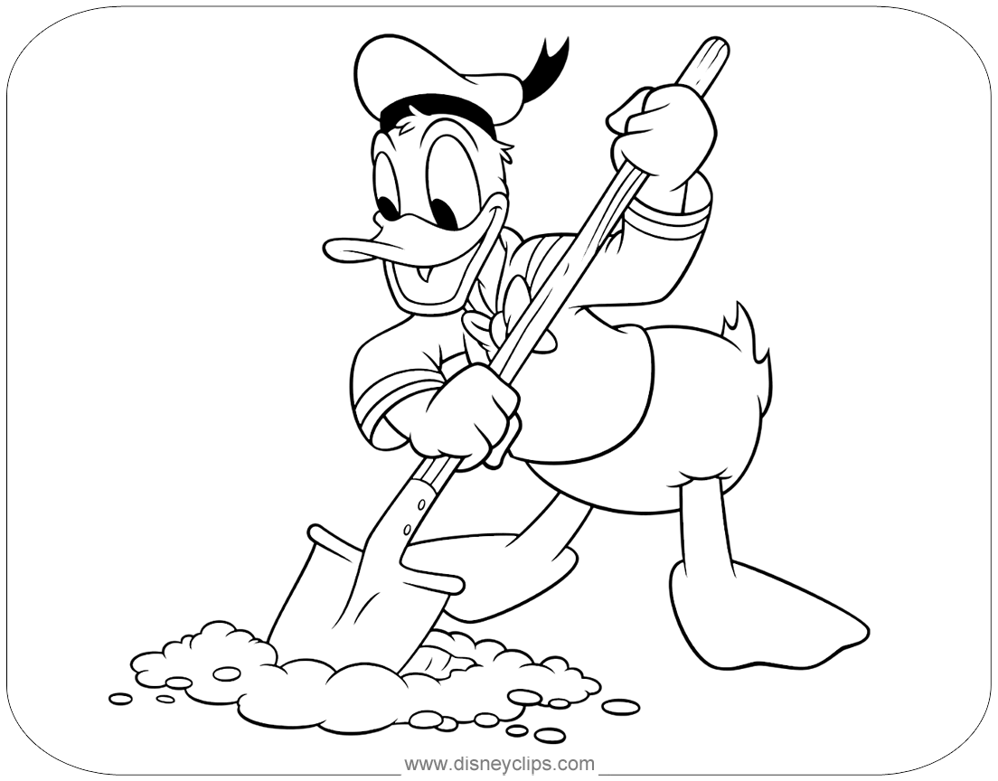

Please practise writing your full name and your letters.
Full Name:

.....................................................................................

