This week we have revised previous sounds and started to investigate the digraph ‘oi’ and the ‘ear’ trigraph.
Please label the pictures below.
Tricky word spellings ; like you are they
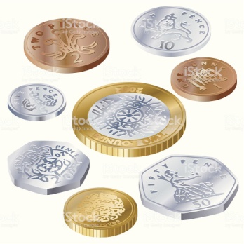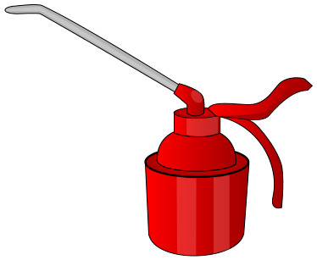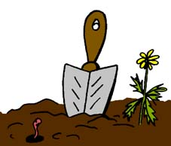

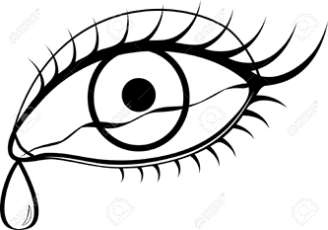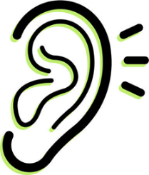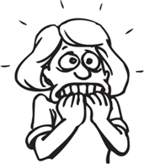

Adults the pictures are ; boil, coin, oil, soil, point, tear, ear and fear.

Can you read the word below?
beard boil gear foil year coil tear
Can you write a sentence or a question using two of the words from the pictures above.
Make sure you pick one from each sound.

